**Lab 6.1**

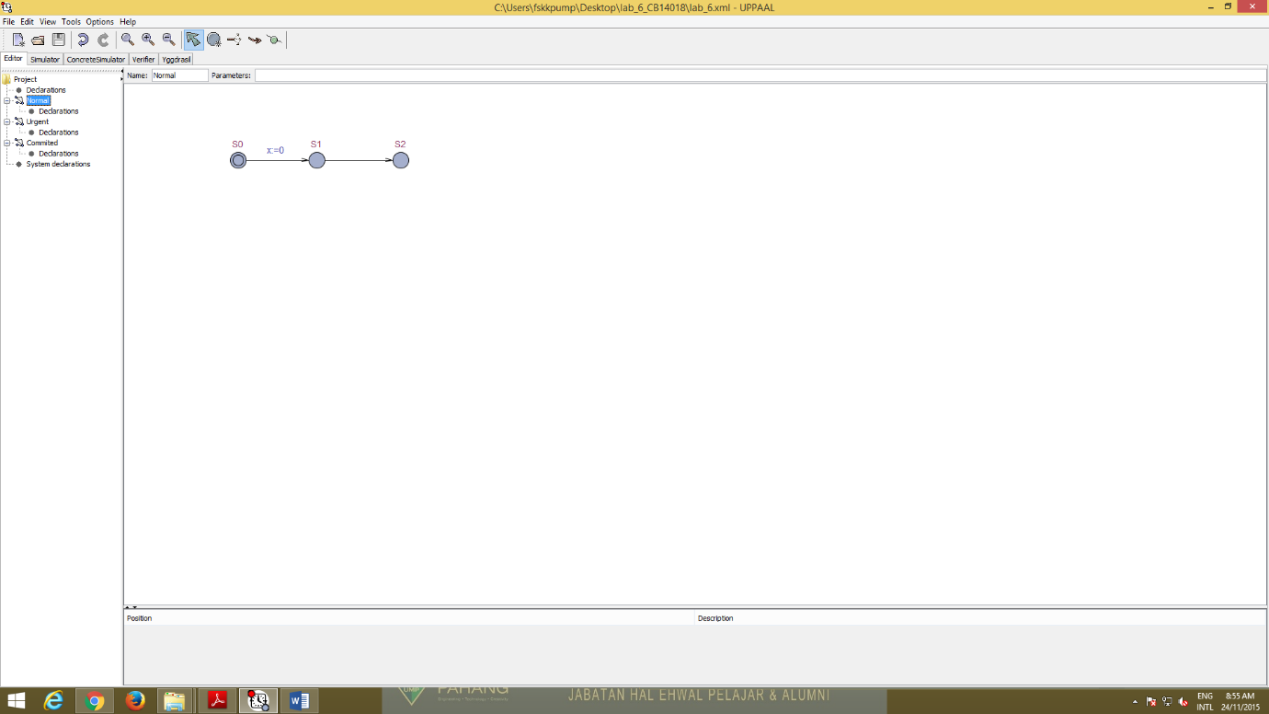

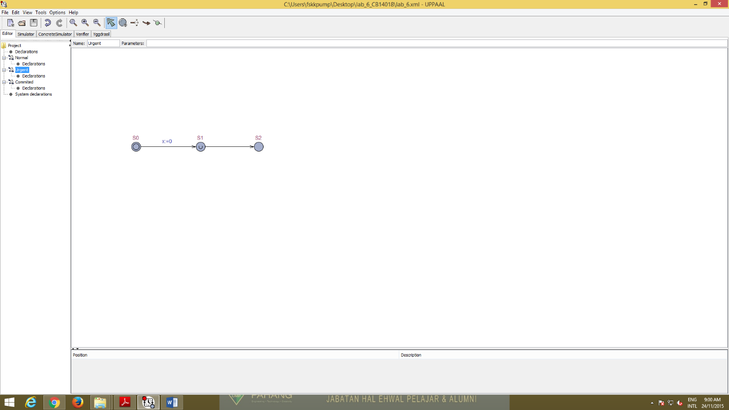

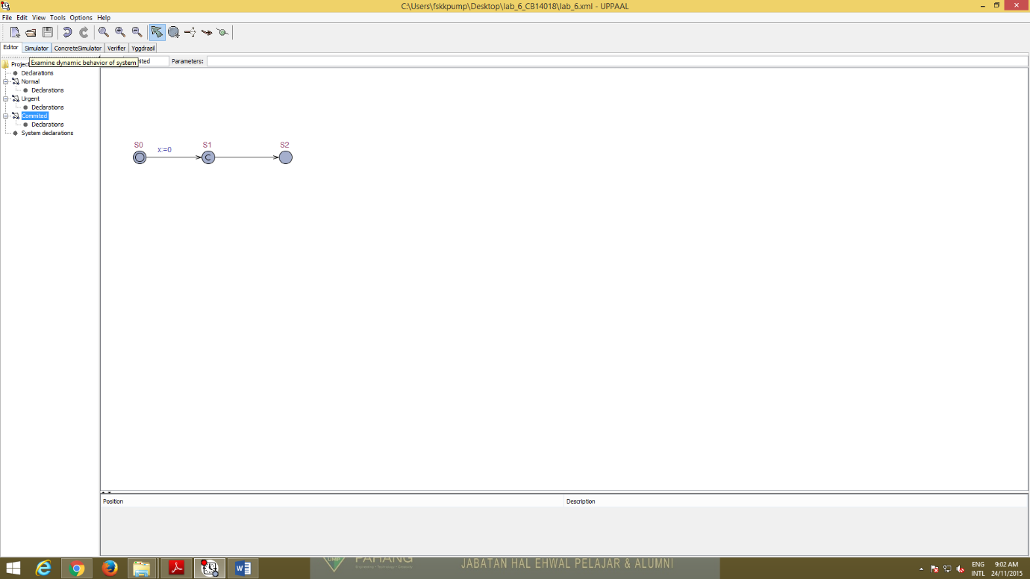

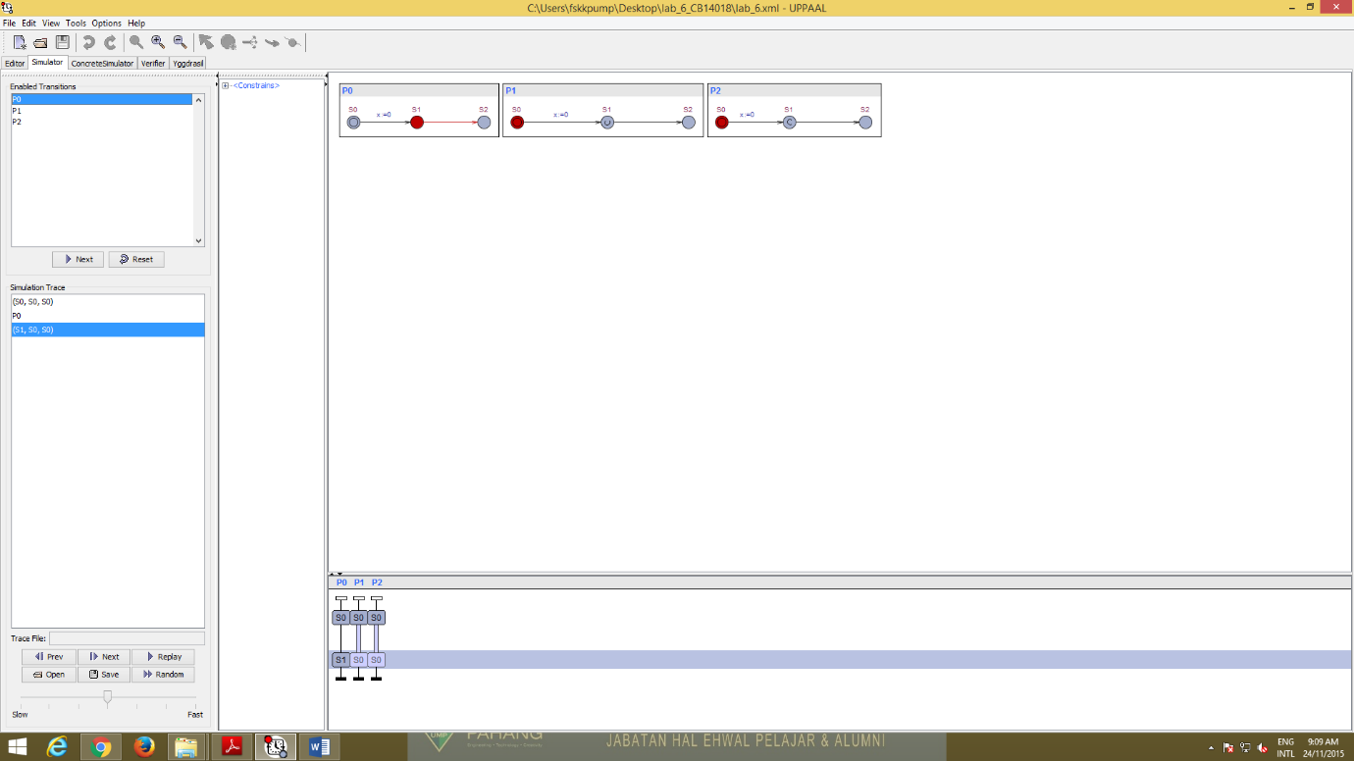

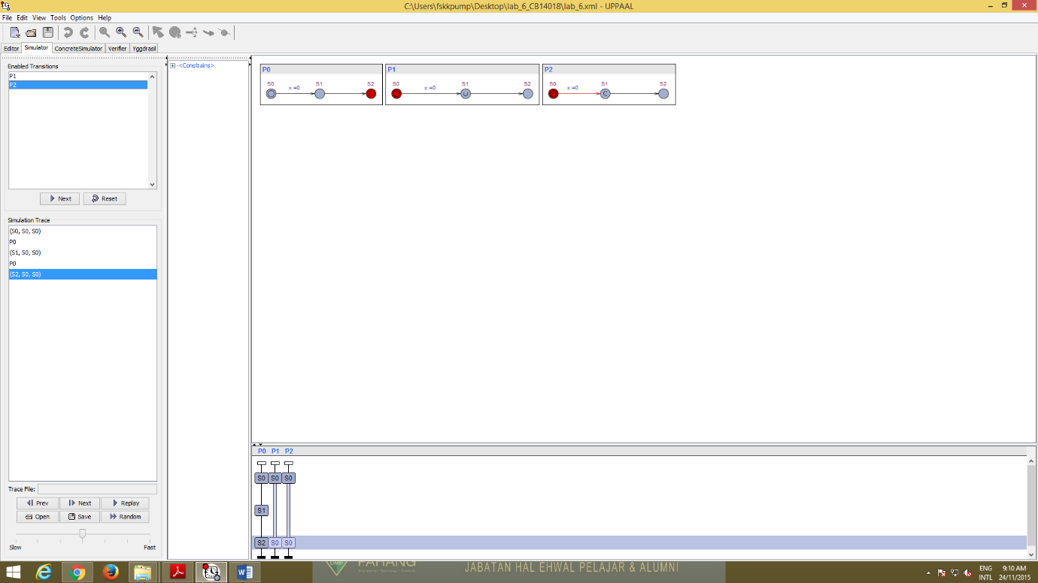

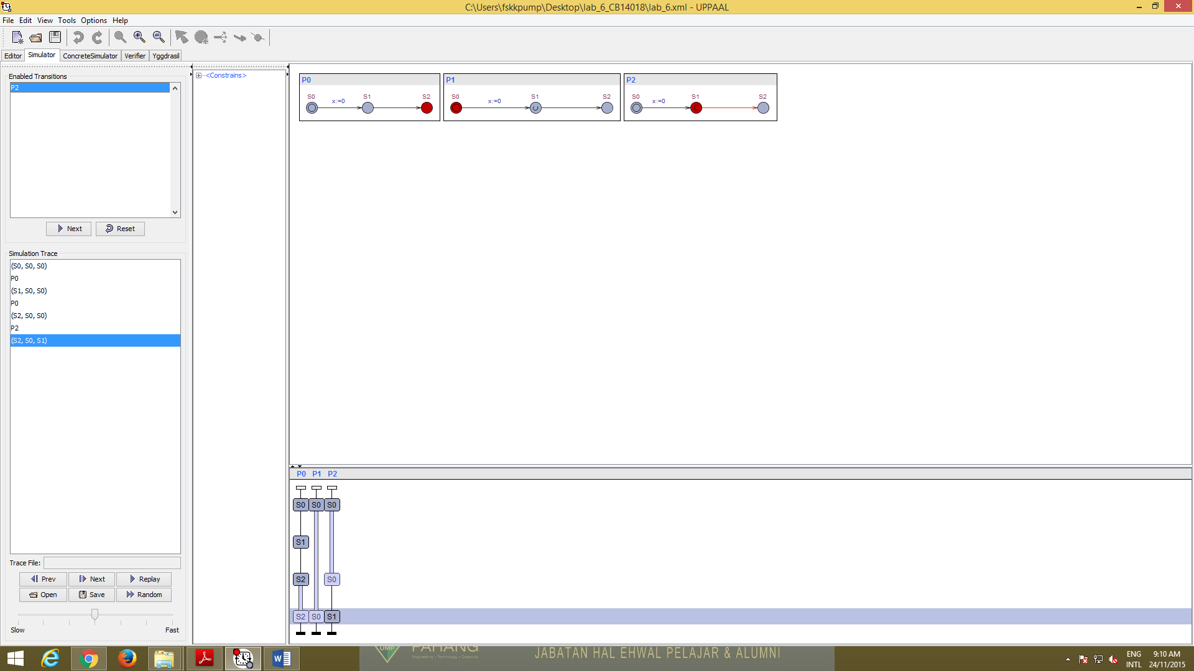

This model describe about three different types of locations in UPPAAL that are normal locations, urgent locations and committed locations. Then, when we try in verifier for committed the only possible transition is always the one going out of the committed and has to be left immediately.

For normal state the property is E<> P0.S1 and P0.x>0 so it is true because it is possible to wait in S1 of P0 for normal location.

Next, for urgent state the property is A[]P1.S1 imply P1.x==0 so it is true because it is not possible to wait S1 of P1 for urgent location.

So we can conclude, that time may not pass in an urgent state, but interleaving’s with normal states are possible. That means urgent location are less strict than committed.

**Lab 6.2**

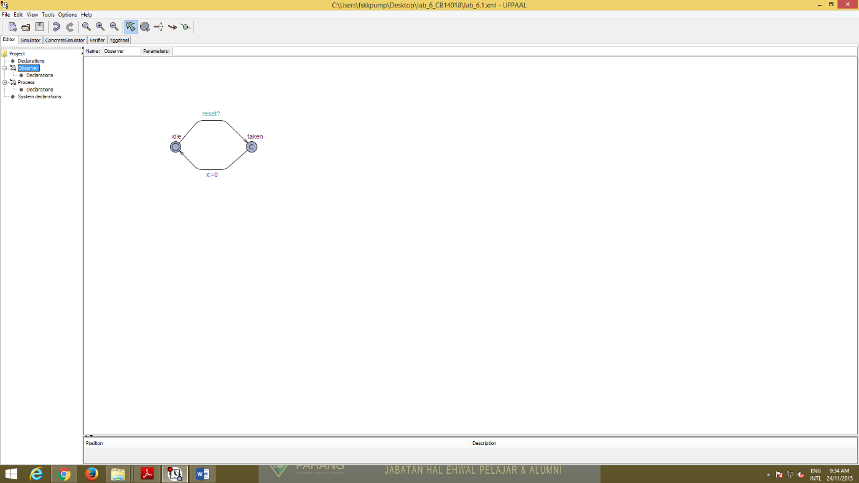

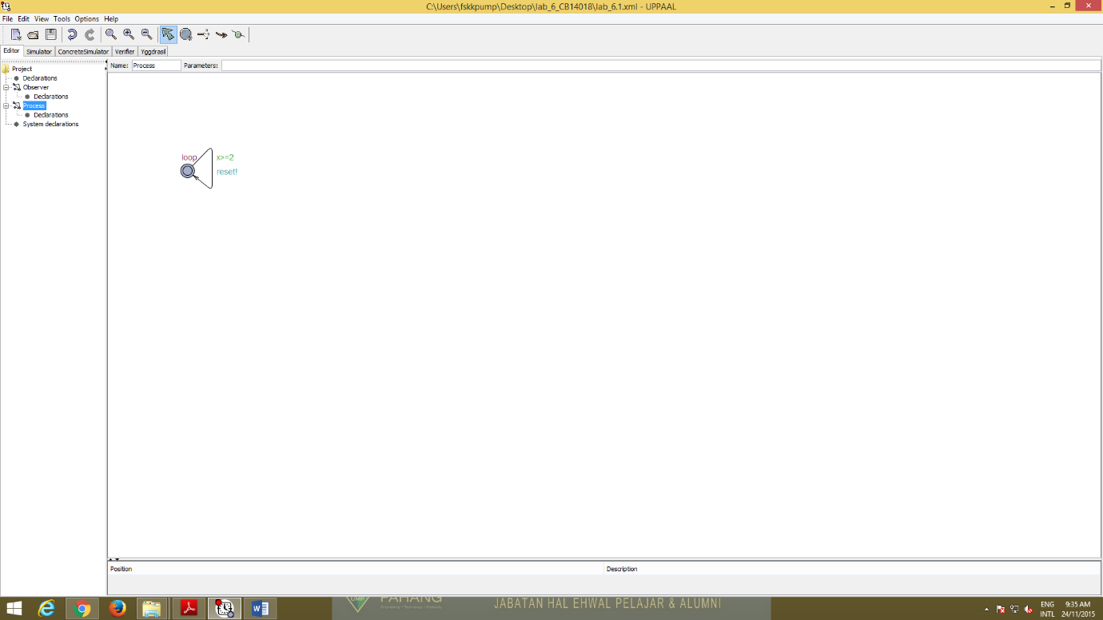

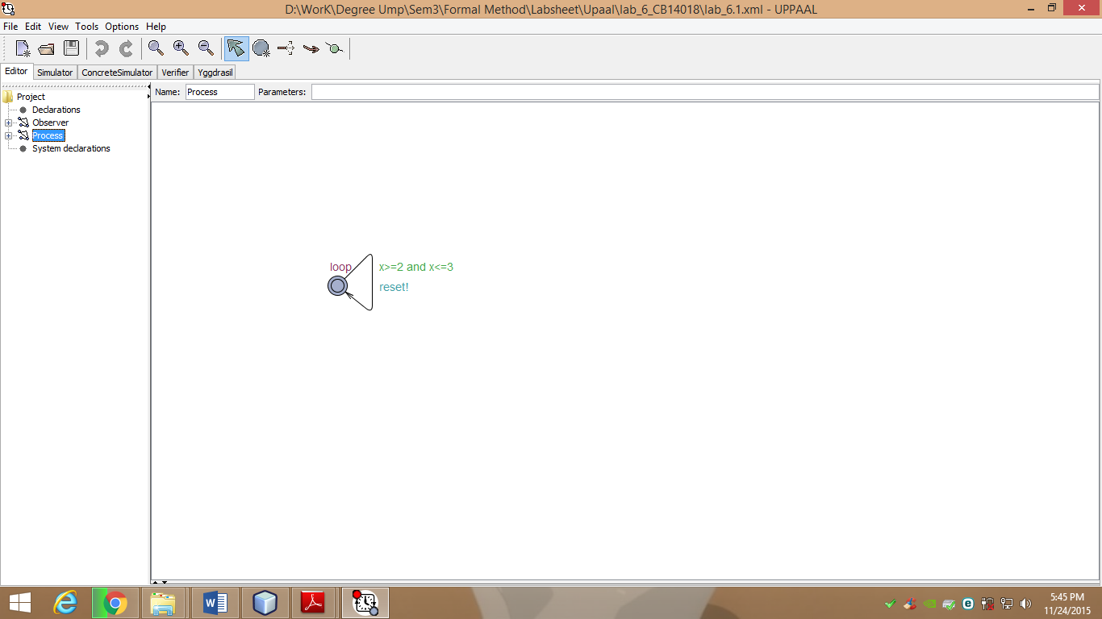

The observer is a type of committed because no delay is allowed to occur and any action transition must involve the component committed to continue.

The property of A[] obs.taken imply x>=2 is all fall down of the clock value are above 2. It also means that for all states, being in the location obs.taken value of time x should be more equal 2.

For property of E<>Obs.idle and x>3 is to check the waiting period and it also means that it possible to reach a state whether Obs is in the location idle and x>3.

Then, if we also try the property of E<>Obs.idle and x>3000 the result also same with the x>3 that is it possible to reach a state where Obs is in the location idle and X>3000.

When we try the property of A[] x>3 imply not Obs.taken in verifier it will be a deadlock because after 3 times units the transition cannot be taken anymore.

If the guard of transition change to x>=2 and x<=3 it is not same as before but the system has no progress condition anymore and just a new condition on the guard now.